**Project 1 - Farkle**

# **1 Introduction**

Farkle is a game that has been played under various names, rule sets, and styles. I chose to program the game Farkle in a way how I used to play it which makes matches much more difficult, random, and quick. Normally in Farkle the user is allowed multiple rolls and decides which dice they are allowed to score, but in this variation scoring is based on whatever the first roll is. This style of Farkle is much quicker than the usual because there are many less rolls, but there is more randomness as the game is less controlled by the user and more controlled by chance.

# **2 Game Play and Rules**

Farkle is a dice game in which there are two players. The first player rolls one dice, followed by the second player, and whichever player gets the higher roll goes first. Each turn is taken by the player rolling six dice. The rolls are then scored based on 1s, 5s, 3 of a kind, 4 of a kind, 5 of a kind, and 6 of a kind. If the player cannot score anything then their entire score is reset back to zero and they have “Farkled.” This does not mean they have lost, there is still a chance for them to win by reaching the score limit of 10,000 before the other player who can also “Farkle” at any time. The goal of the game is to reach 10,000 before the other player, and the first player to reach or surpass the score limit is the winner.

# **3 Development Summary**

The basis of the game was fairly easy to code, but perfecting it and the scoring took some time. The program, at first, would not display the correct winner after one of the players wins the game, so instead of hardcoding in the player number who won, the player variable was used which fixed this issue. The scoring system of the program took some time and thought, however, it worked out very well in the end by just using variables to count how many one, twos, threes, fours, fives, and sixes were rolled and then using if statements to check for 3, 4, 5, and 6 of a kinds rather than just trying to check for each permutation of those rolls with each individual dice variable. Once a winner is found the both players’ scores are sent to a scorekeeping file named “Farkle.txt” as a sort of “memory” for the game.

# **4 Flowchart**

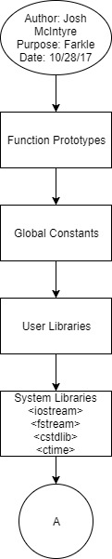

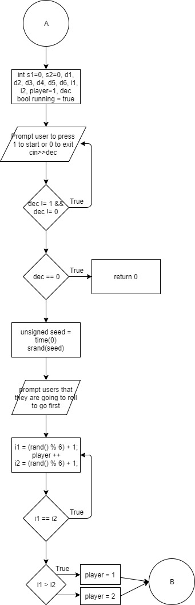



















# **Code**

Github - <https://github.com/JMAK13/McIntyreJosh_CSC_5_Fall2017/blob/master/Projects/Project%201/Farkle/main.cpp>

# **Checklist**

